DIGITAL ASSIGNMENT-3

NAME: GADAMSETTY RISHITHA REG. NO: 20BIT0200

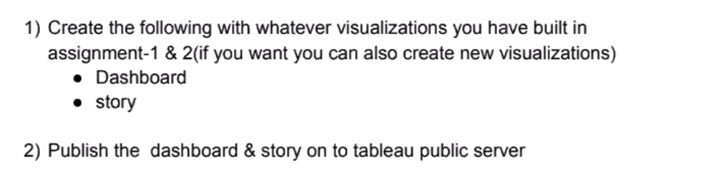

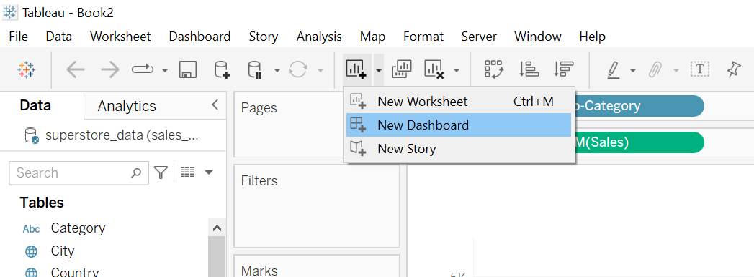

Drag all the sheets onto the dashboard..

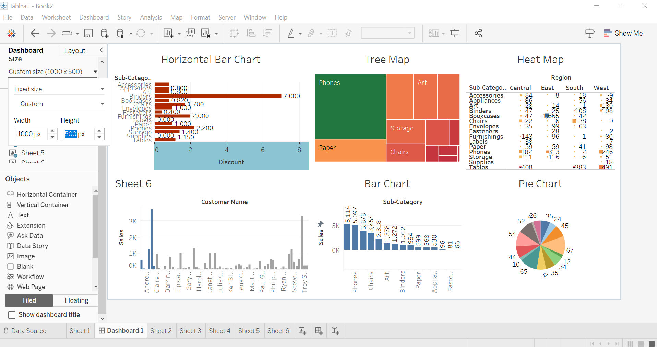

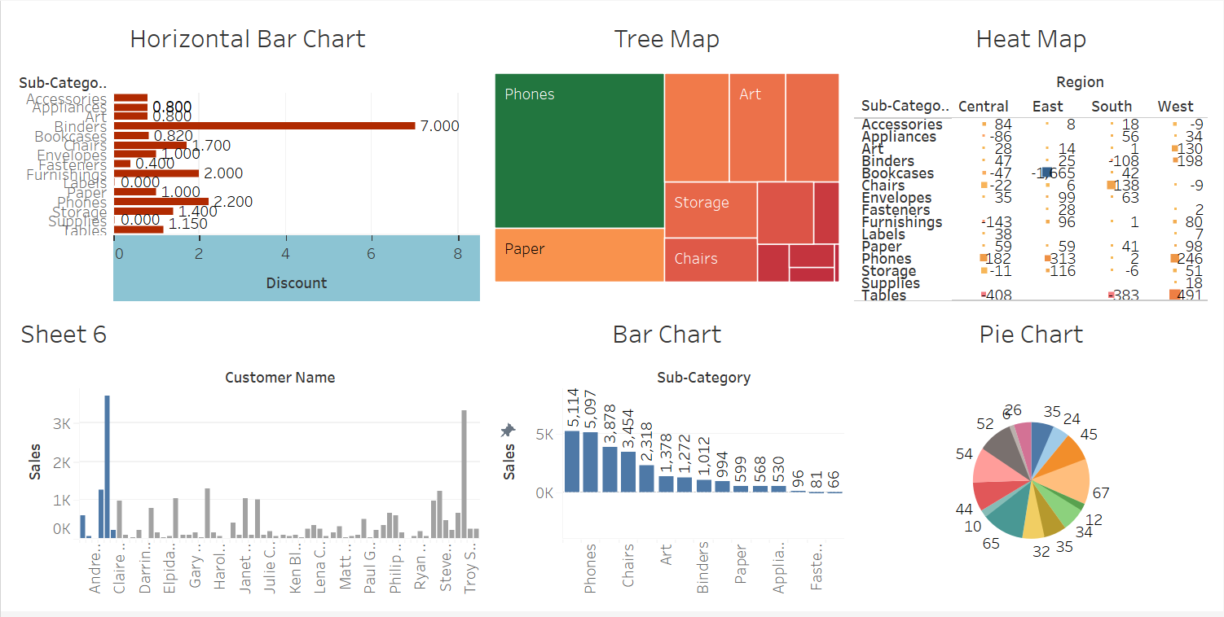

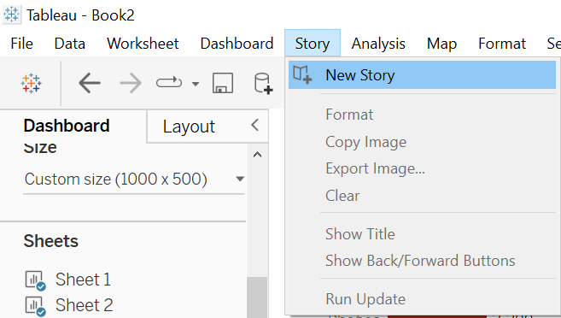

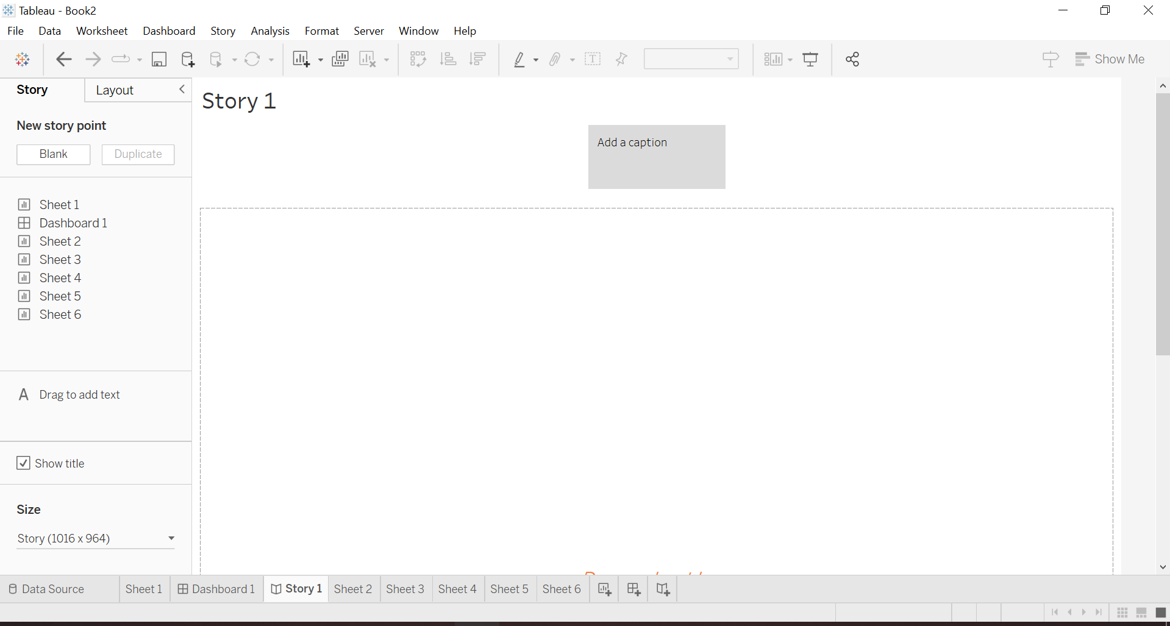

You can write caption for every sheet

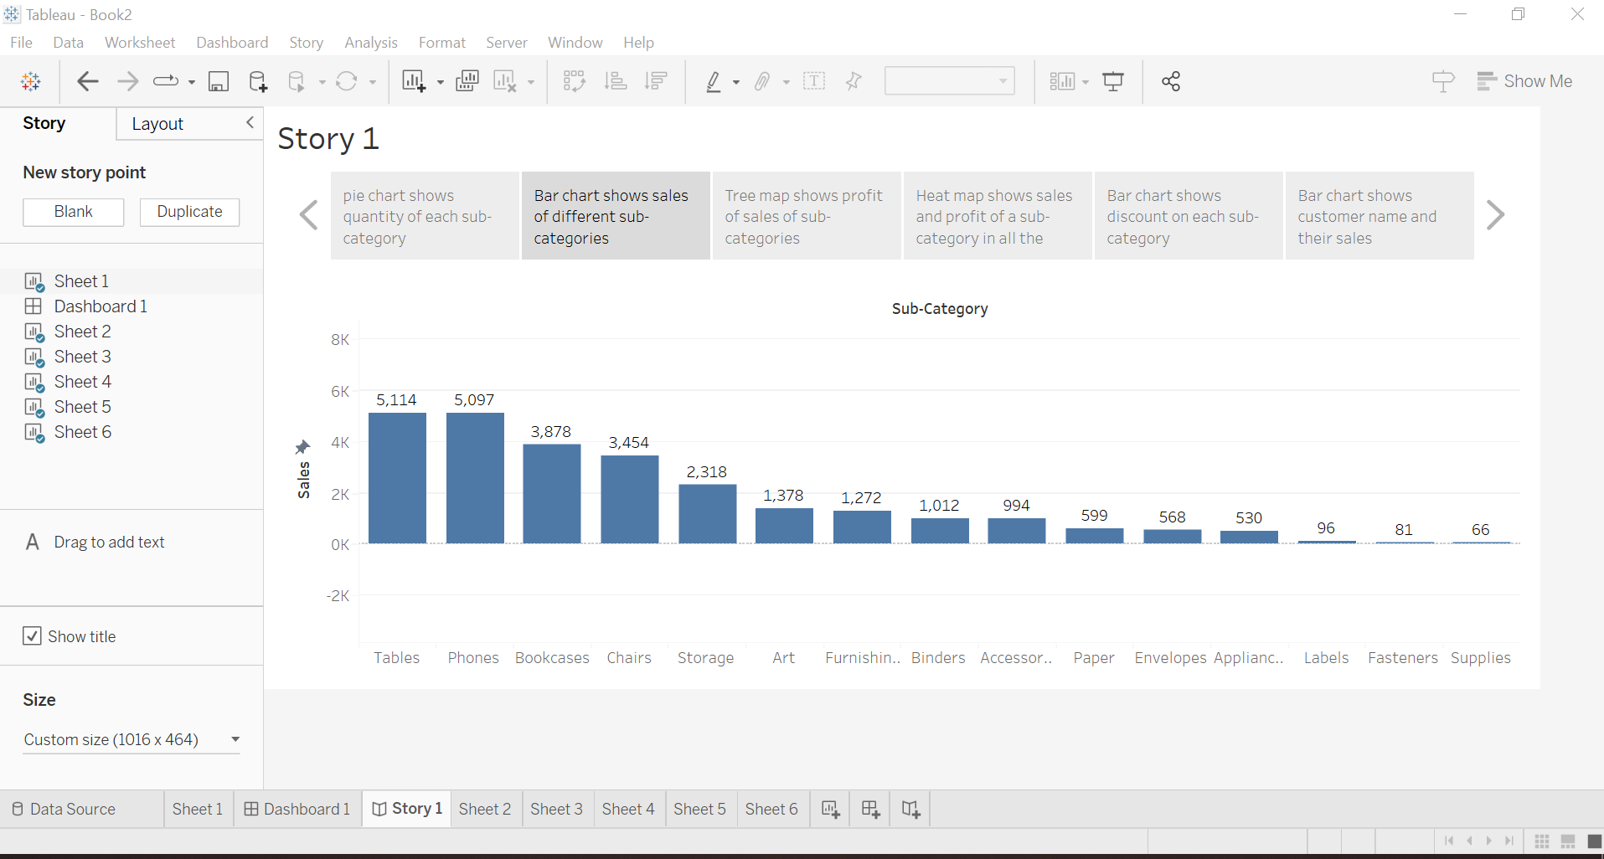

Now we will publish the created dashboard and story on the tableau public server



Click on this symbol

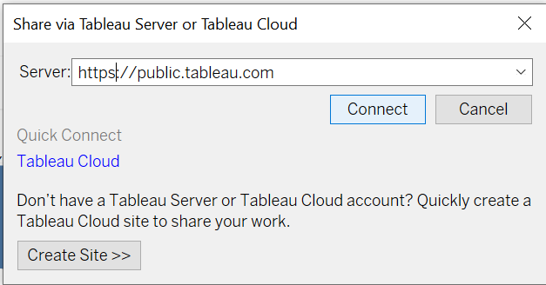

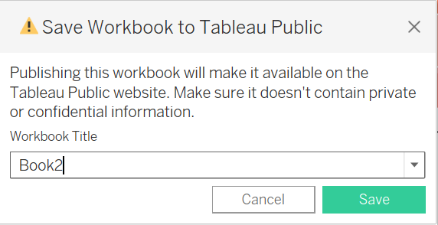

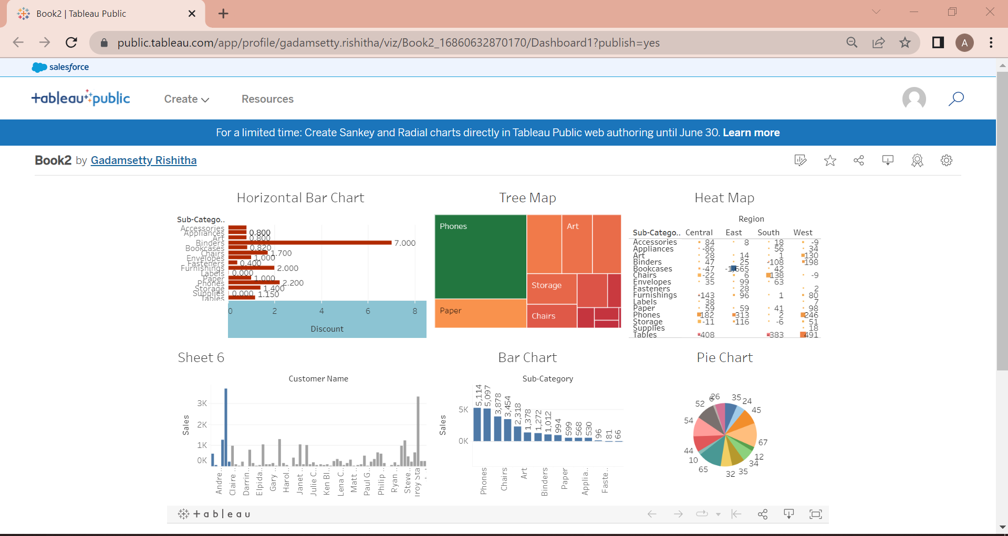

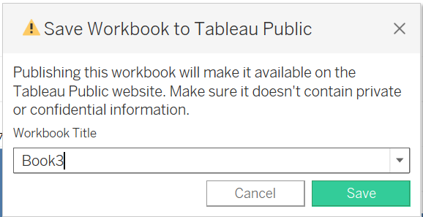

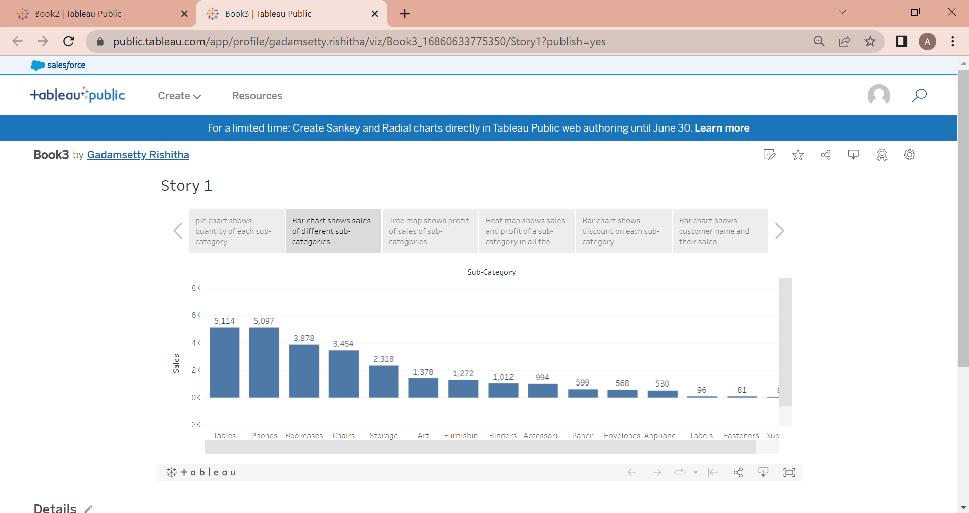

Story link:

<https://public.tableau.com/views/Book3_16860633775350/Story1?:language=en-US&publish=yes&:display_count=n&:origin=viz_share_link>

Dashboard link:

<https://public.tableau.com/views/Book2_16860632870170/Dashboard1?:language=en-US&publish=yes&:display_count=n&:origin=viz_share_link>